The Pursuit of Happyness
[Name]
[Institute Affiliation]
[Professor]
[Course]

The Pursuit of Happyness: Chris Gardner gives speech to his son Christopher about not giving up on your dreams.

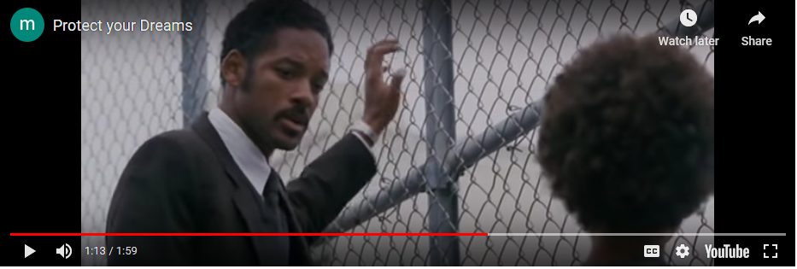

Fact: Close up shots-

The film the director Gabriele Muccino uses many close-up shots to help convey to the audience Chris Gardner and his son Christopher’s facial expressions and emotions as they tackle life’s trials and tribulations. A close-up shot is taken of a subject or object at close range that shows greater detail. The shot is tightly framed and is most often used to frame a character’s face in such a way that it fills the screen and dominates the scene.( https://nofilmschool.com/Close-up-shot-uses-and-examples) The close shot provides the viewer a detailed and intimate look at a character and is the best tool a director has for conveying a character’s emotional state of mind; it draws us into the subject’s space and helps us understand their feelings.
Idea: Gabriele Muccino uses the close-up shot’ to help the audience feel the emotions and pain that Chris Gardner and his son experience as they travel life’s unpredictable journey. In the scene where Chris and his son are playing basketball, he said , “ you know you probably be as good as I was that’s kind of the way it works and I was bellow average so you will ultimately rank the same you will excel at a lot of things just not this” The camera then proceeds to do a close up of Christopher’ slamming the basketball against the fence in frustration. It is at that point in the scene the camera pans to Gardner clinching on a fence tightly with his hand and his head in a downward position indicating to the audience he is not proud of himself for putting his sons dreams down.

